# Resizable jQuery UI object

To implement the requirement of resizing jQuery UI object, we create a webpage named maps.html which use the Google Map’s API to display the map of west coast, be specific, the San Francisco bay area.

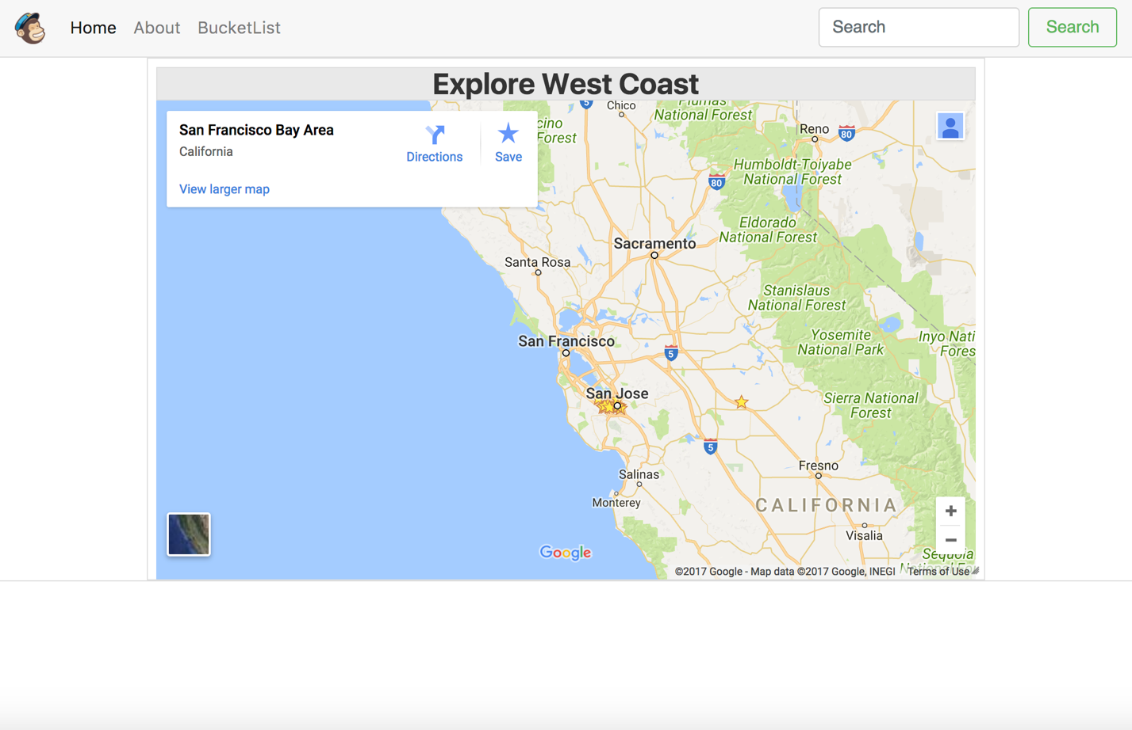

Users have to click the link which says map on the homepage and then users can resize the map by putting the mouse on the small triangle on right-bottom corner, and then click it and hold it. The map can get bigger which allows the users to see more places displayed on the map.

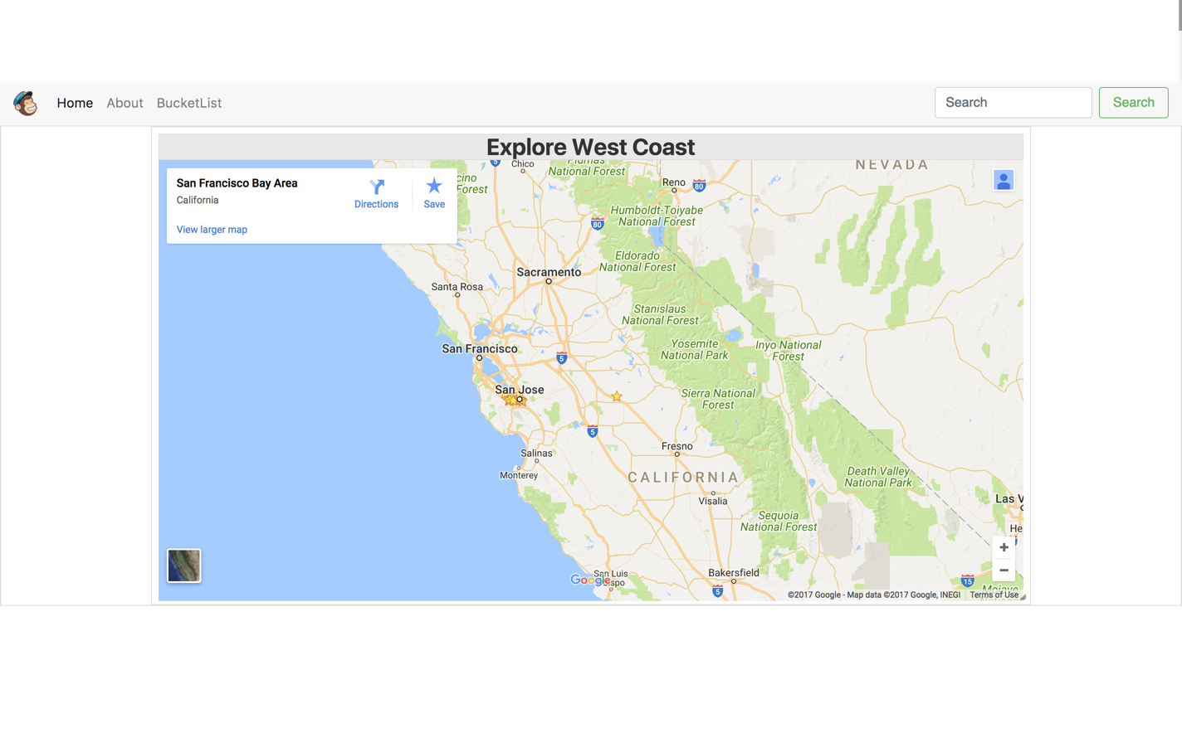

The jQuery and html code snippet that enable this functionality is shows below:

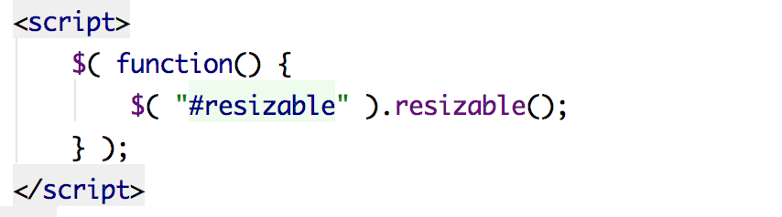

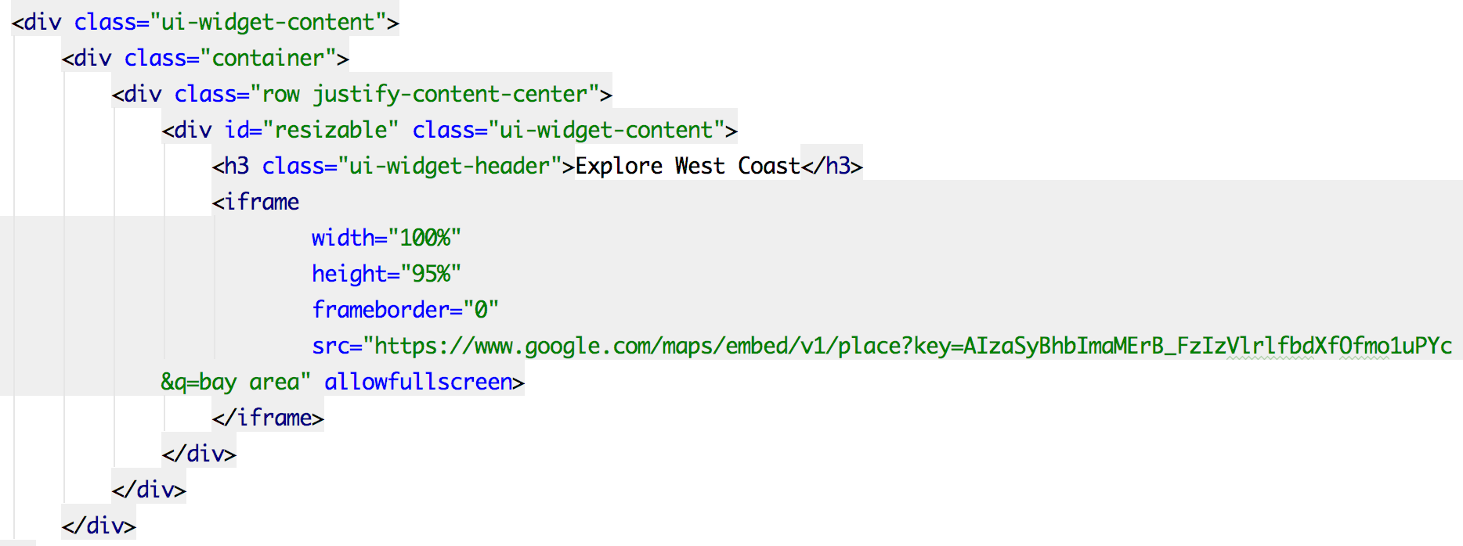

jQuery’s resizable() function is declare first thing in the <head>, and only works with the <div> that has the id of ‘resizable’.

In the html file, we create a <div> with id = “resizable” and a class = “ui-widget-content” which is a built-in class. And as a result, we can see the map is resizing based on the size of the block.

# Dragged and dropped jQuery UI object

To implement the requirement of having a screen object that is dragged and dropped, we have created a web page in our application whose functionality is to help the user create a bucket list.

Bucket list is a list of places that he user plans to visits, from the recommendations given by tour guide.

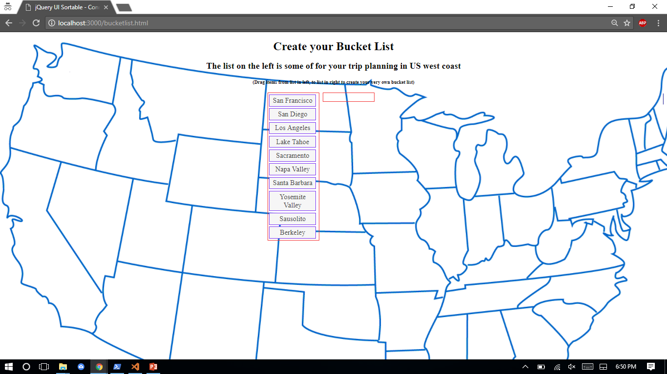

As we can see there are two lists in the web page, the first list is a list that recommends places to visit and the second list is an empty one. It is the user’s bucket list which he or she can fill by dragging and dropping items from the first list.

The following screenshot shows an item being dragged from one list to the other one and then eventually dropped.

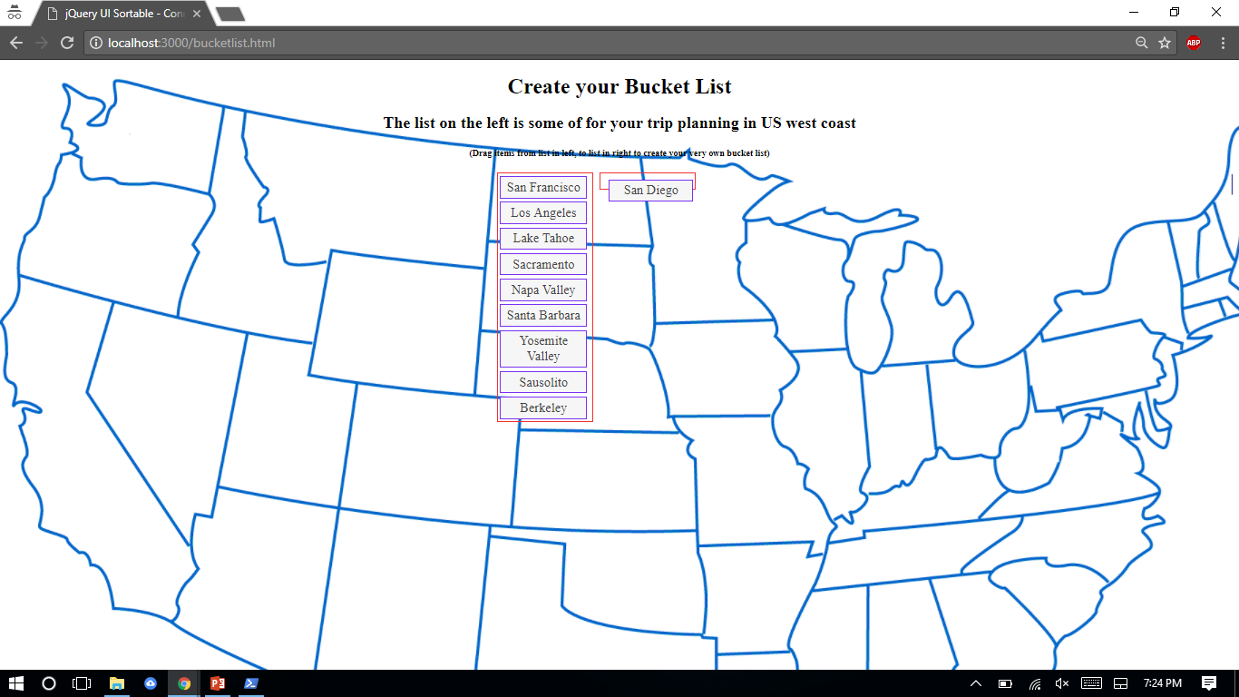

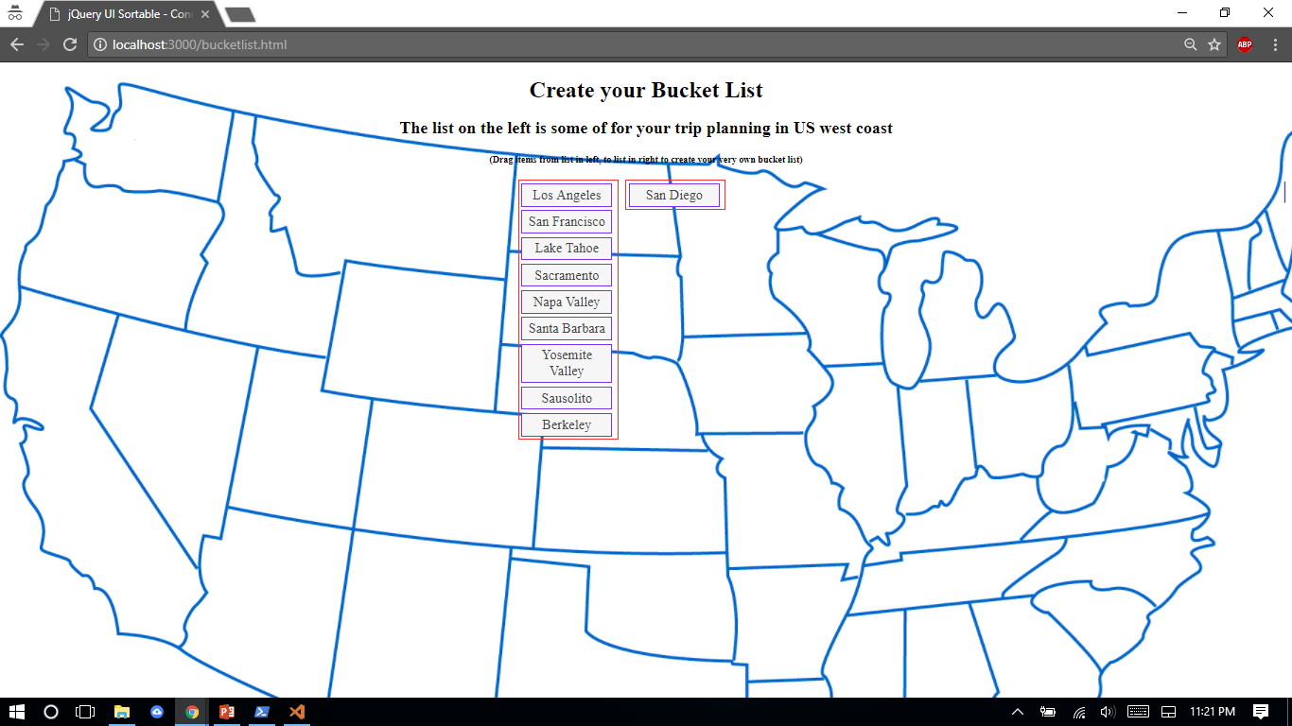

The jQuery code snippet that enables this functionality is shows below:

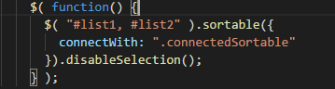

jQueryUI’s sortable() method has been used for ordering the elements in both the lists.

The selectors(list1 and list2) have been specified in the method as the elements on which the sortable action has to be performed.

‘connectWith’ is a Selector that identifies another sortable element that can accept items from the other sortable elements defined. Using this property, we are able to move items from list to another.This is a one-way relationship. By default its value is false.

‘Disableselection’ ensures that the text inside the list elements is not selected while the list elements are being dragged from one list to another.

# AJAX tabs

We use AJAX tabs to show information about the city to users. It has 3 items: Intro, Food and Tour. Users could get relevant information in them. Users could change the content in the tab by clicking the tags.

Here is how it works:





To implement AJAX tabs, we use the .tabs() function from jQuery and use html files as the link in the corresponding items in the tabs. When users click the tags, the server will load the html file to be the content of tabs.

AJAX tabs in html:

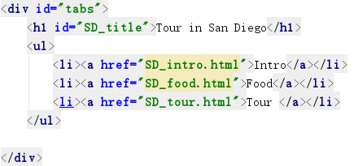

AJAX tabs in js:

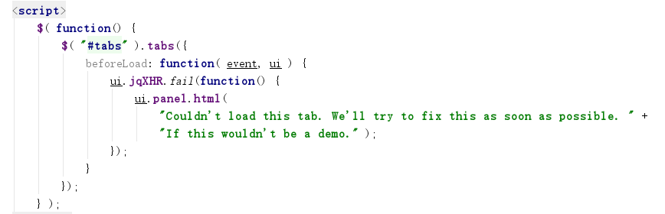

# Interactive jQuery UI widgets:

## Widget#1:

The first widget we implemented is auto-completion for the search bar on our homepage. The search bar is designed for users to find specific information they want for certain places on west coast of U.S.



Here is how it works. The purpose of auto-completion is to help users to type in the places faster and more easily even when they forget how to spell the names of those cities.

To implement this, we first need to import jQuery and jQuery UI source files. Then we need to add the places in the jQuery code as follows:

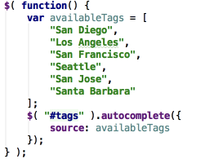

In the HTML code part, we need to give class name “ui-widget” to the division which contains the input tag for the search bar. Last but not least, the id “tags” is needed for the input for the auto-completion function to work.

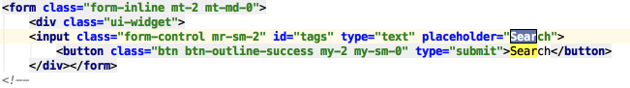

## Widget#2:

The second widget we implemented is the tooltip for sign up page. When a new user trying to sign up for an account, the system will gently inform them the criteria for both user names and passwords. The purpose of this widget would be to help users to sign up for an account easily.

Here is the screenshot for how it works:

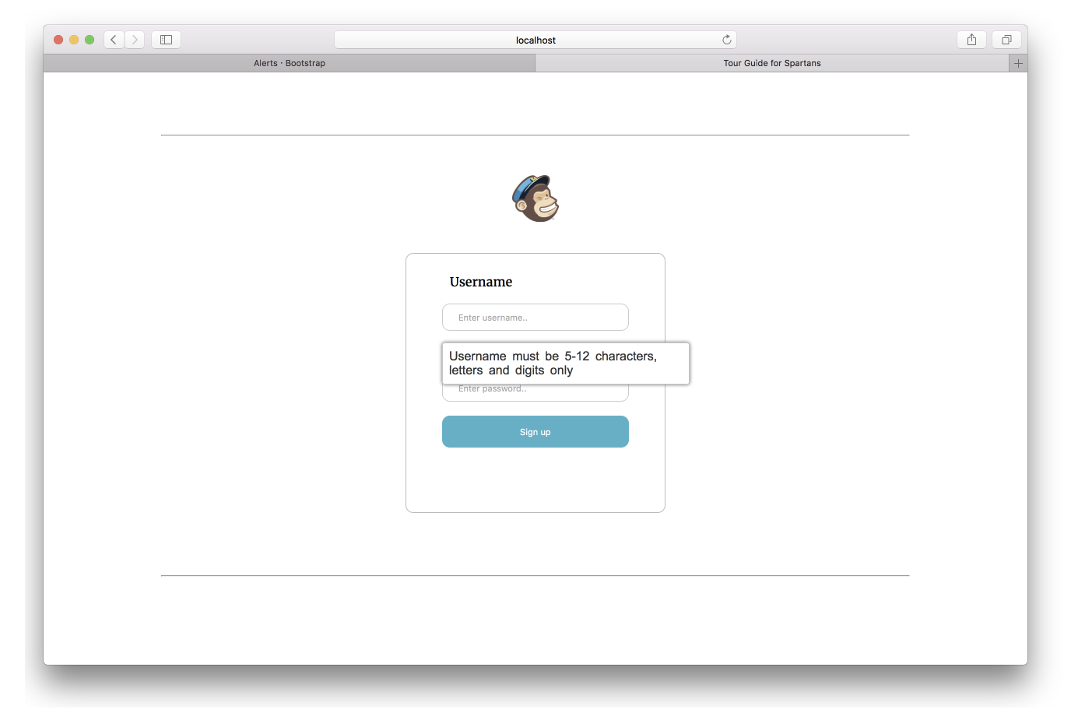

When the mouse is placed in the username or password input box, this information will be displayed to tell users that Username (or Password) must be 5-12 characters long, letters and digits only.

To implement this, we also need to import jQuery and jQuery UI files from online resources. Then, we only need to write this in the script tag:

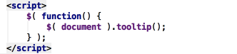

In the HTML code of those input boxes,

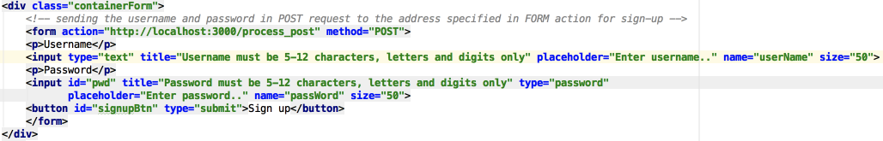

we just need to add a title attribute for input tag then the tooltip will be shown when users trying to type in their own usernames and/or passwords.

## Widget#3:

The third widget we implement is a date-picker. The date-picker will allow users of our website to select the date he/she plans to start their trips to a certain place. Our website will later give them better suggestions like events during those dates at their destinations to help them better enjoy their trips.

Here is how this widget works:

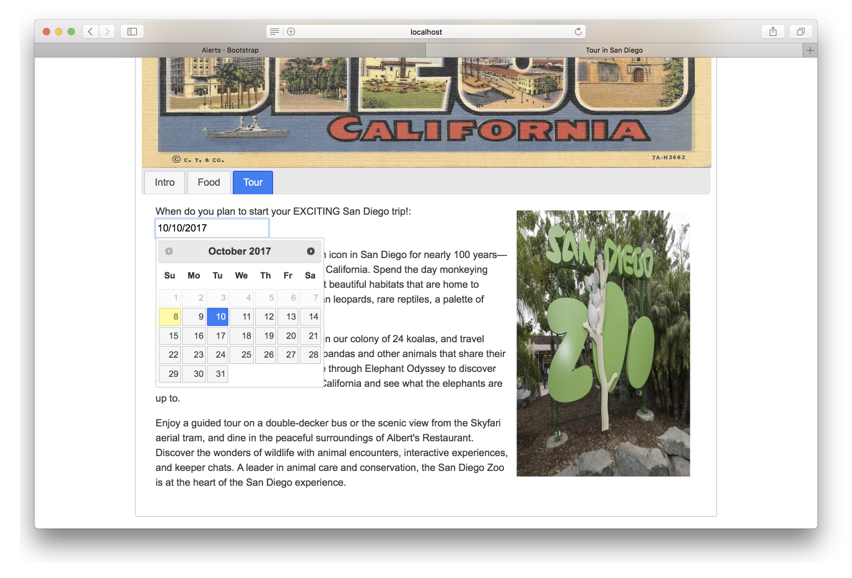

Users are only allowed to choose a future date since you can’t plan to start your trip before current date.

To implement this, we first need to import jQuery and jQuery UI source files. Then we need to specify this in the script tag:

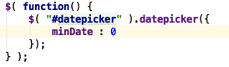

minDate: 0 here means only future dates are allowed. Then in the HTML code of this part,

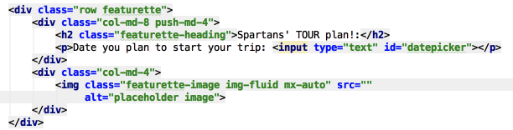

we need to give id “datepicker” to the input box for this widget to work.